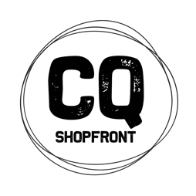
CQ Shopfront
Artisan in Residence Mentorship Program
Expression of Interest

The CQ Shopfront Program is a 2-year developmental program to build the business capacity of visual artists and makers across 7 local government areas in Central Queensland and to encourage the development of commercially viable products.

As part of this program, Ipswich-based artist Marc Harrison will be Artisan in Residence at Community Lifestyle Support’s Maki Space and Bundaberg Regional Art Gallery from the 14th to 26th June 2021. Marc will be creating new work, running workshops and offering a mentoring program for up to 6 Bundaberg Region artists and makers.
https://www.husque.com

What does the Mentorship Program offer?
Marc will be inviting the mentees to work alongside him at the Maki Space for 3 days a week for the 2 weeks of the residency. He will share information about his practice, talk to mentees about their business and product development needs and co-work in the space towards the creation of new product inspired by the by-products of local industry. This challenge being set by Marc can be interpreted in any medium that the mentees may already be working in or they may like to experiment with a variety of techniques given Marc’s skills and experience and the facilities and team at the Maki Space.

Mentees will be required to attend a minimum of 3 per week (on week days) during the course of the residency and to provide their own materials and tools whilst working in the space. Access to the space and mentoring with Marc is funded and will be at no cost to the mentee other than materials and self-catering.

How do you apply?
Please complete the form attached and submit to Shelley Pisani via email – shelley@theideasdistillery.net – by Monday 11th January. The successful candidates will be chosen and notifications given by Friday 29th January 2021. To be eligible you must be:
- A resident of the Bundaberg Region
- Have a demonstrated visual arts practice that is either currently being operated as a business or is emerging as a business
- A participant in the CQ Shopfront program to date in some way or a willingness to get involved

CQ Shopfront is a project of The Ideas Distillery. A special thank you to Arts Queensland, the Regional Arts Fund, Flying Arts Alliance, Bundaberg Regional Council and their RADF Program, CQ RASN and CQ University, Bundaberg Regional Galleries, Macadamias Australia, Community Lifestyle Support and Artisan for supporting the Bundaberg iteration of the CQ Shopfront Artisan in Residence Program.

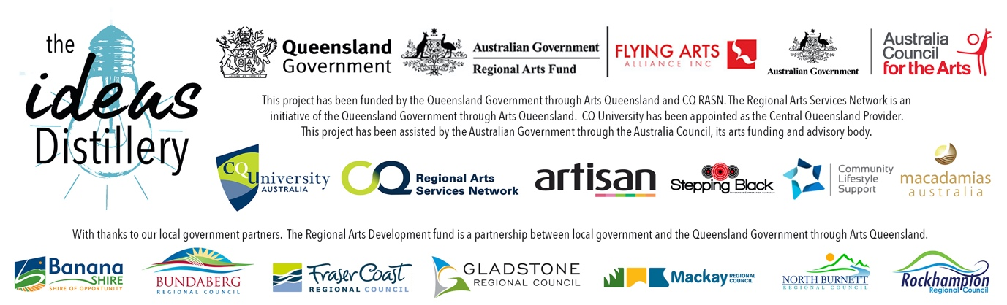

EXPRESSION OF INTEREST FORM
APPLICANT’S NAME
MOBILE PHONE
DAYTIME CONTACT (IF DIFFERENT)
EMAIL
POSTAL ADDRESS
SOCIAL MEDIA LINKS TO YOUR PRACTICE
WEBSITE
IN WHAT WAYS HAVE YOU PARTICIPATED IN THE CQ SHOPFRONT PROJECT TO DATE?
WHAT DO YOU HOPE TO GET OUT OF THIS MENTORSHIP OPPORTUNITY?

PLEASE ATTACH THE FOLLOWING TO YOUR EMAIL SUBMISSION:
- A signed copy of this form
- A 1-page curriculum vitae that is focused on your arts practice
- A 1-page description of your practice and your business or ideas for a business
- If you do not have social media or a website where we can view your work, please submit up to 6 images of your work

TERMS AND CONDITIONS
- By signing this form you are confirming that you are a resident of the Bundaberg Regional Council area.
- You confirm that you have actively participated in the CQ Shopfront project as stated above and that you are interested in building your creative business.
- You will make yourself available for 3 weekdays per week during the timeframe of the residency
- You agree to work in a collaborative environment with the Artisan in Residence and other mentees and contribute to an exhibition outcome.
- You agree to complete an exit survey after your participation in the residency.

Signature ________________________
Name ________________________
Date ____/____/202_

