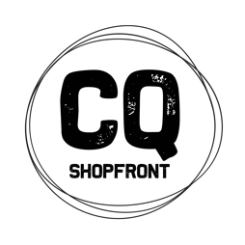
CQ Shopfront
Artisan in Residence Mentorship Program
Expression of Interest

The CQ Shopfront Program is a 2-year developmental program to build the business capacity of visual artists and makers across 7 local government areas in Central Queensland and to encourage the development of commercially viable products.

As part of this program, Ipswich-based artist Rebecca Lewis is the Artisan in Residence for the Fraser Coast. Rebecca will be creating new work, running workshops and offering a mentoring program for up to 6 Fraser Coast artists and makers.
https://www.thefinderskeepers.com/blog/2016/06/five-questions-with-little-brown-dog-workshop/

What does the Mentorship Program offer?
Rebecca will be inviting the mentees to work alongside online and in person. She will share information about her practice, talk to mentees about their business and product development needs and co-work in the space towards the creation of new work around the theme of “House Portraits” utilising lino printing and locative animation.

Rebecca will be offering the following:
- Locative and Stop Motion Collage Workshop on Saturday 16th January at Gatakers Artspace, Maryborough (bookings open now at: https://www.theideasdistillery.net/event-details/cq-shopfront-locative-and-stop-motion-collage-with-rebecca-lewis). There will be an opportunity to catch up face to face with mentees following this workshop.
- Online mentoring will also be offered.
- Rebecca will also be visiting for 4 days in May 2021 (dates to be confirmed) in line with the Open House event in Maryborough, with an exhibition being held at The Story Bank, Maryborough. Mentees can participate in this exhibition.

Access to the space and mentoring with Rebecca is funded and will be at no cost to the mentee other than materials and self-catering. There is a small charge for workshop attendance.

How do you apply?
Please complete the form attached and submit to Shelley Pisani via email – shelley@theideasdistillery.net – by Monday 11th January. The successful candidates will be chosen and notifications given by Thursday 14th January 2021. To be eligible you must be:
- A resident of the Fraser Coast region
- Have a demonstrated visual arts practice that is either currently being operated as a business or is emerging as a business
- A participant in the CQ Shopfront program to date in some way or a willingness to get involved

CQ Shopfront is a project of The Ideas Distillery. A special thank you to Arts Queensland, the Regional Arts Fund, Flying Arts Alliance, Fraser Coast Regional Council and their RADF Program, CQ RASN and CQ University, Gatakers Artspace, The Story Bank and Artisan for supporting the Maryborough iteration of the CQ Shopfront Artisan in Residence Program.

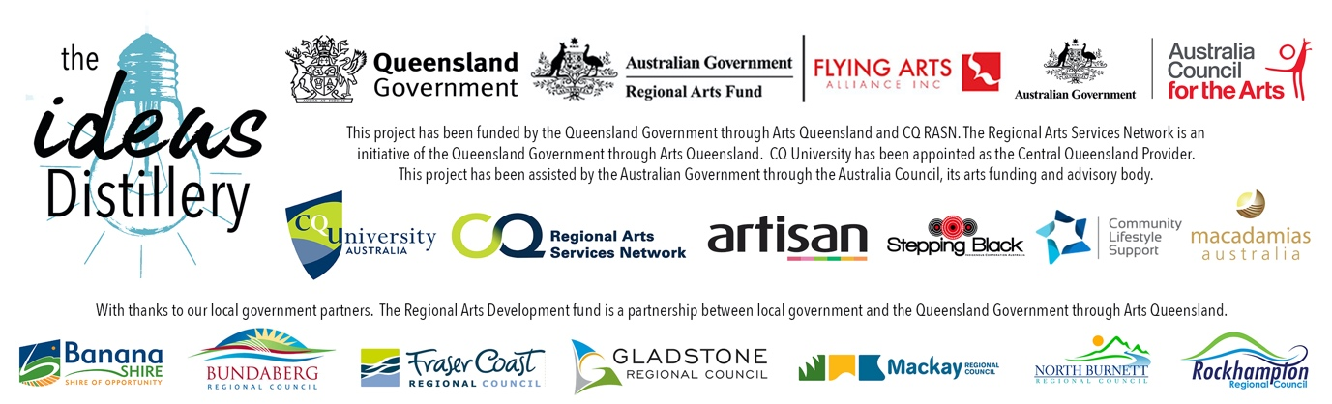

EXPRESSION OF INTEREST FORM
APPLICANT’S NAME
MOBILE PHONE
DAYTIME CONTACT (IF DIFFERENT)
EMAIL
POSTAL ADDRESS
SOCIAL MEDIA LINKS TO YOUR PRACTICE
WEBSITE
IN WHAT WAYS HAVE YOU PARTICIPATED IN THE CQ SHOPFRONT PROJECT TO DATE?
WHAT DO YOU HOPE TO GET OUT OF THIS MENTORSHIP OPPORTUNITY?

PLEASE ATTACH THE FOLLOWING TO YOUR EMAIL SUBMISSION:
- A signed copy of this form
- A 1-page curriculum vitae that is focused on your arts practice
- A 1-page description of your practice and your business or ideas for a business
- If you do not have social media or a website where we can view your work, please submit up to 6 images of your work

TERMS AND CONDITIONS
- By signing this form you are confirming that you are a resident of the Fraser Coast Regional Council area.
- You confirm that you have actively participated in the CQ Shopfront project as stated above and that you are interested in building your creative business.
- You will make yourself available for mentorship opportunities
- You agree to work in a collaborative environment with the Artisan in Residence and other mentees and contribute to an exhibition outcome.
- You agree to complete an exit survey after your participation in the residency.

Signature ________________________
Name ________________________
Date ____/____/202_

