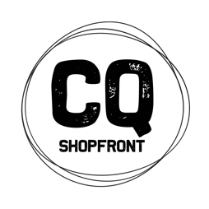
CQ Shopfront
Artisan in Residence Mentorship Program
Expression of Interest

The CQ Shopfront Program is a 2-year developmental program to build the business capacity of visual artists and makers across 7 local government areas in Central Queensland and to encourage the development of commercially viable products.

As part of this program, Brisbane-based designer Kiara Bulley is the Artisan in Residence for the North Burnett. Kiara will be creating new work, running workshops and offering a mentoring program for up to 6 North Burnett artists and makers.
https://thestitcherycollective.org.au
https://www.bulleybulley.com

What does the Mentorship Program offer?
Kiara will be inviting the mentees to work alongside her online and in person. She will share information about her practice, talk to mentees about their business and product development needs and co-work in the space towards the creation of new work around the theme of “Heart on your Sleeve”. This project will ask these artists to develop and create adornment (clothing, jewellery, accessories etc) that reflects elements of the North Burnett area and its people that they treasure.

KIARA IS IN THE NORTH BURNETT THIS WEEK delivering workshops in Gayndah, Monto and Eidsvold.

Mentoring will also take place online via Zoom meet ups with the aim of creating new work and building your practice.

Kiara’s second visit will be in April to scout locations and conduct a fashion photo shoot with a fashion photographer. An exhibition will be curated and toured to the RM Williams Centre, Monto and Gayndah (details to be confirmed). Access to the mentoring opportunity with Kiara is funded and will be at no cost to the mentee other than materials and self-catering. There is a small charge for workshop attendance.

How do you apply?
Please complete the form attached and submit to Shelley Pisani via email – shelley@theideasdistillery.net – by Friday 12th March 5pm. The successful candidates will be chosen and notifications given by Friday 19th March 2021. To be eligible you must be:
- A resident of the North Burnett region or willing to pay for own travel from an approved Central Queensland location
- Have a demonstrated visual arts practice that is either currently being operated as a business or is emerging as a business
- A participant in the CQ Shopfront program to date in some way or a willingness to get involved

CQ Shopfront is a project of The Ideas Distillery. A special thank you to Arts Queensland, the Regional Arts Fund, Flying Arts Alliance, North Burnett Regional Council and their RADF Program, CQ RASN and CQ University, Gayndah Art Gallery, RM Williams Centre and Artisan for supporting the North Burnett iteration of the CQ Shopfront Artisan in Residence Program.
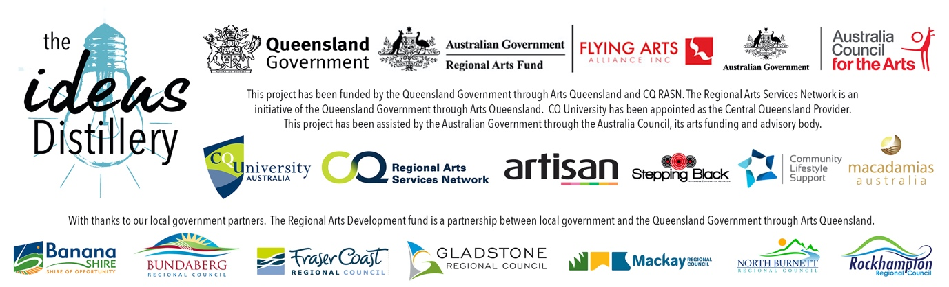

EXPRESSION OF INTEREST FORM
APPLICANT’S NAME
MOBILE PHONE
DAYTIME CONTACT (IF DIFFERENT)
EMAIL
POSTAL ADDRESS
SOCIAL MEDIA LINKS TO YOUR PRACTICE
WEBSITE
IN WHAT WAYS HAVE YOU PARTICIPATED IN THE CQ SHOPFRONT PROJECT TO DATE?
WHAT DO YOU HOPE TO GET OUT OF THIS MENTORSHIP OPPORTUNITY?

PLEASE ATTACH THE FOLLOWING TO YOUR EMAIL SUBMISSION:
- A signed copy of this form
- A 1-page curriculum vitae that is focused on your arts practice
- A 1-page description of your practice and your business or ideas for a business
- If you do not have social media or a website where we can view your work, please submit up to 6 images of your work

TERMS AND CONDITIONS
- By signing this form you are confirming that you are a resident of a participating Central Queensland region.
- You confirm that you have actively participated in the CQ Shopfront project as stated above and that you are interested in building your creative business.
- You will make yourself available for mentorship opportunities
- You agree to work in a collaborative environment with the Artisan in Residence and other mentees and contribute to an exhibition outcome.
- You agree to complete an exit survey after your participation in the residency.

Signature ________________________
Name ________________________
Date ____/____/2021

