CQ Shopfront
Artisan in Residence Mentorship Program
Expression of Interest

The CQ Shopfront Program is a 2-year developmental program to build the business capacity of visual artists and makers across 7 local government areas in Central Queensland and to encourage the development of commercially viable products.
As part of this program, Brisbane-based artist Jeanette Stok will be Artisan in Residence at Crow Street Creative from the 6th to 16th April 2021. Jeanette will be creating new work, running workshops and offering a mentoring program for up to 6 Gladstone Region artists and makers.
https://jeanettestok.com

What does the Mentorship Program offer?
Jeanette will be inviting the mentees to work alongside her at Crow Street for 3 days a week for the 2 weeks of the residency. She will share information about her practice, talk to mentees about their business and product development needs and co-work toward the development of a large collaborative new sculptural work themed around “Boats”. This theme can be interpreted in any medium that the mentees may already be working in or they may like to experiment with sculpture techniques given Jeanette’s skills and experience in the practice. The collaborative nature of this mentorship will have your forming a community of likeminded thinkers to share skills and ideas.

Mentees will be required to participate on 3 weekdays per week during the course of the residency and to provide their own materials and tools whilst working in the space. Access to the space and mentoring with Jeanette is funded and will be at no cost to the mentee other than materials and self-catering. The mentee’s work will be included in a showcase night at Crow Street Creative on Friday 16th April 2021.

The scheduled Mentee Co-Working days are:

- Tuesday 6th April
- Wednesday 7th April
- Thursday 8th April
- Tuesday 13th April
- Wednesday 14th April
- Thursday 15th April

How do you apply?
Please complete the form attached and submit to Shelley Pisani via email – shelley@theideasdistillery.net – – by Friday 12th March 5pm. The successful candidates will be chosen and notifications given by Friday 19th March 2021. To be eligible you must be:
- A resident of the Gladstone Region or willing to pay for own travel from an approved Central Queensland location
- Have a demonstrated visual arts practice that is either currently being operated as a business or you are exploring ways of growing your practice

CQ Shopfront is a project of The Ideas Distillery. A special thank you to Arts Queensland, the Regional Arts Fund, Flying Arts Alliance, Gladstone Regional Council and their RADF Program, CQ RASN and CQ University, Crow Street Creative and Artisan for supporting the Gladstone iteration of the CQ Shopfront Artisan in Residence Program. 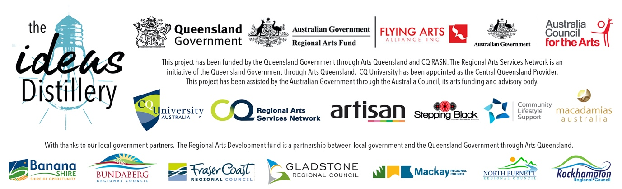

EXPRESSION OF INTEREST FORM
APPLICANT’S NAME
MOBILE PHONE
DAYTIME CONTACT (IF DIFFERENT)
EMAIL
POSTAL ADDRESS
SOCIAL MEDIA LINKS TO YOUR PRACTICE
WEBSITE
IN WHAT WAYS HAVE YOU PARTICIPATED IN THE CQ SHOPFRONT PROJECT TO DATE?
WHAT DO YOU HOPE TO GET OUT OF THIS MENTORSHIP OPPORTUNITY?

PLEASE ATTACH THE FOLLOWING TO YOUR EMAIL SUBMISSION:
- A signed copy of this form
- A 1-page curriculum vitae that is focused on your arts practice
- A 1-page description of your practice and your business or ideas for a business
- If you do not have social media or a website where we can view your work, please submit up to 6 images of your work

TERMS AND CONDITIONS
- By signing this form you are confirming that you are a resident of a participating Central Queensland region.
- You confirm that you have actively participated in the CQ Shopfront project as stated above and that you are interested in building your creative business.
- You will make yourself available for 3 weekdays per week during the timeframe of the residency (dates and times will be confirmed in advance if you need to take leave).
- You agree to work in a collaborative environment with the Artisan in Residence and other mentees and contribute to an exhibition outcome.
- You agree to complete an exit survey after your participation in the residency.

Signature ________________________
Name ________________________
Date ____/____/2021

